**DAILY ONLINE ACTIVITIES SUMMARY**

|  |  |  |  |  |  |  |  |  |
| --- | --- | --- | --- | --- | --- | --- | --- | --- |
| **Date:** | **15-06-2020** | | | | | **Name:** | **Preethi** | |
| **Sem & Sec** | **6th - B** | | | | | **USN:** | **4AL17CS065** | |
| **Online Test Summary** | | | | | | | | |
| **Subject** | | **1.Programming in C** 2.Applications of Python Programming in DA and ML | | | | | | |
| **Max. Marks** | | **1. 3 Quizes-19**  **2. 20** | | **Score** | | | **1. 18**  **2. 18** | |
| **Certification Course Summary** | | | | | | | | |
| **Course** | Workshop on “Applications of Python Programming in DA and ML” | | | | | | | |
| **Certificate Provider** | | | **-** | | **Duration** | | | **-** |
| **Coding Challenges** | | | | | | | | |
| **Problem Statement:1 Java program** | | | | | | | | |
| **Status: executed** | | | | | | | | |
| **Uploaded the report in GitHub** | | | | | **Yes** | | | |
| **If yes Repository name** | | | | | <https://github.com/PreethiNayak/Daily-Status/tree/master/15June2020> | | | |
| **Uploaded the report in slack** | | | | | **Yes** | | | |

Online Test Details: (Attach the snapshot and briefly write the report for the same)

Programming in C

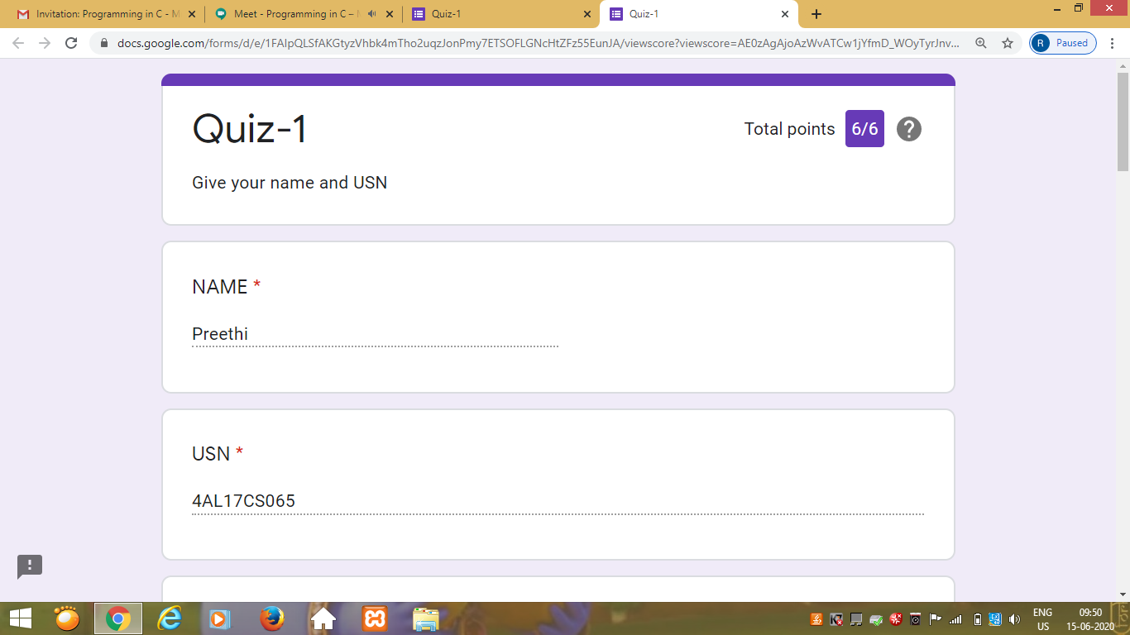

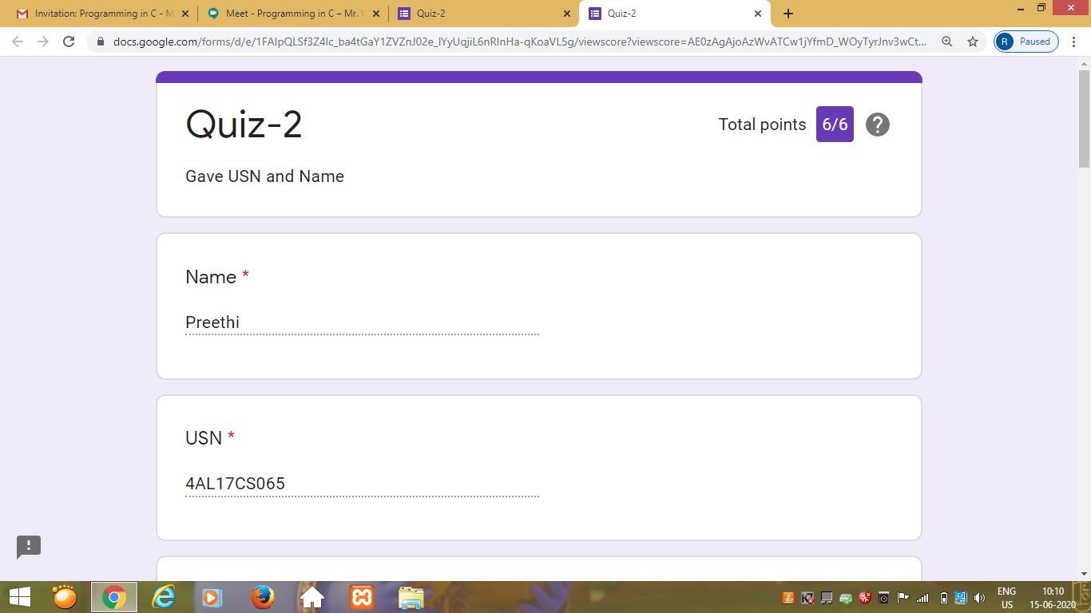

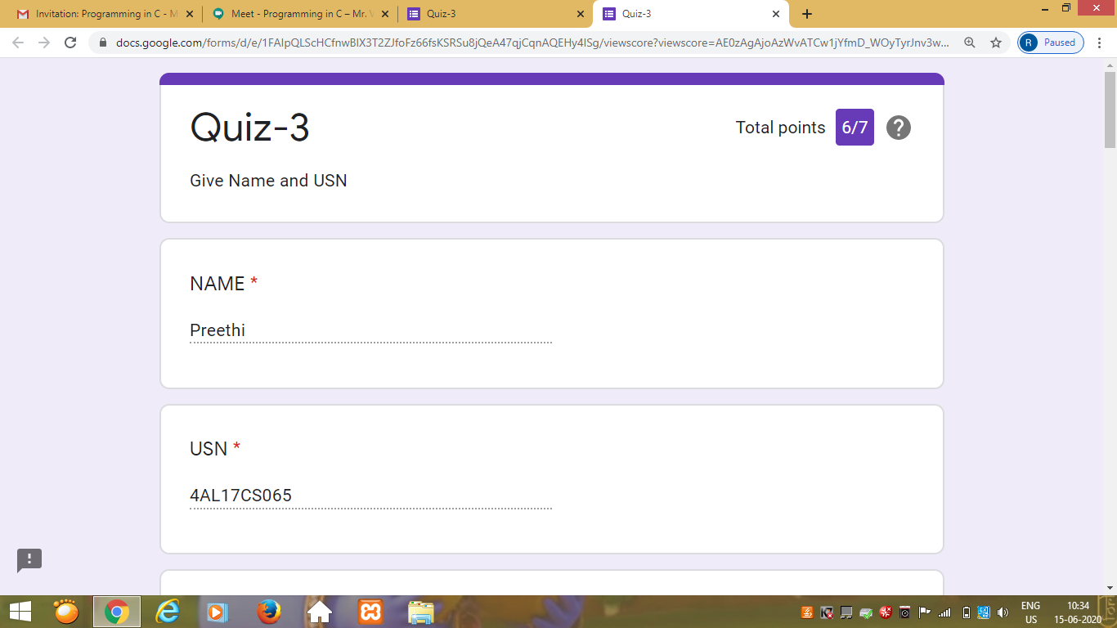

Certification Course Details: (Attach the snapshot and briefly write the report for the same)

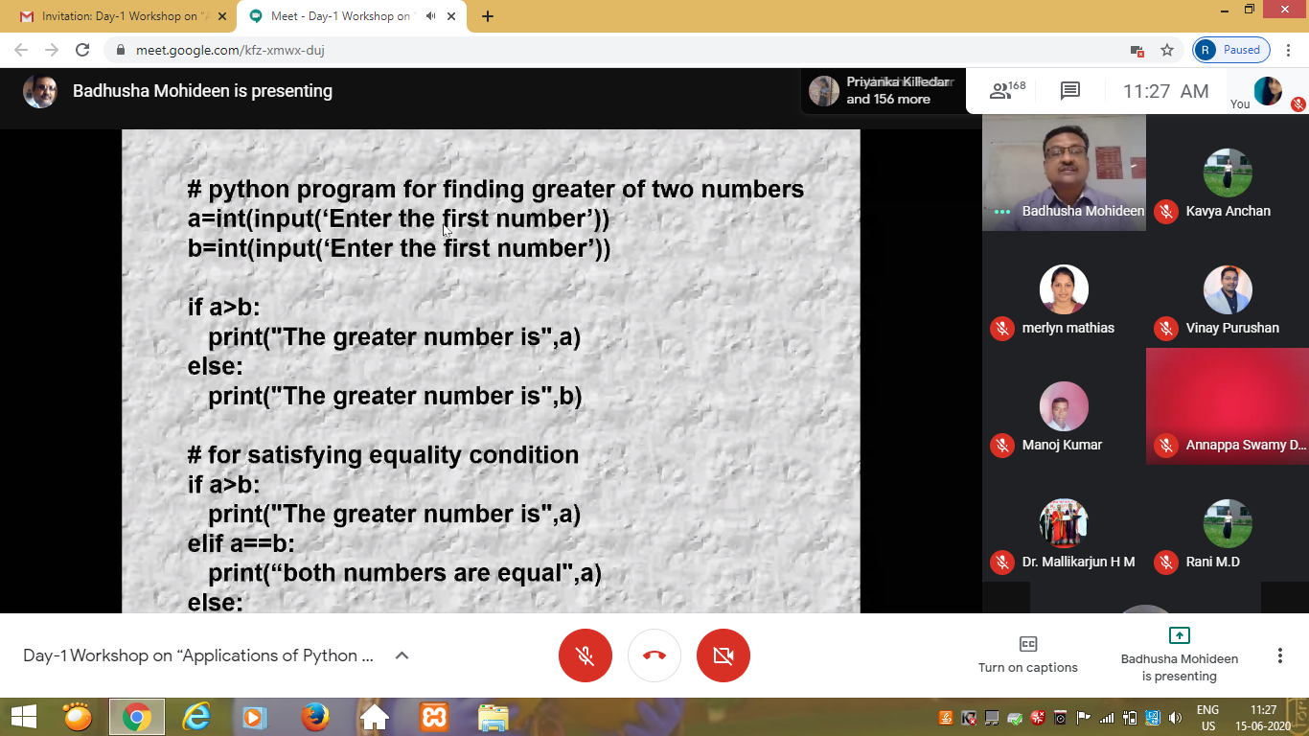

Coding Challenges Details: (Attach the snapshot and briefly write the report for the same)

Program 1

This is output of java program to Find the Middle Node of a Linked list in a Single-pass.

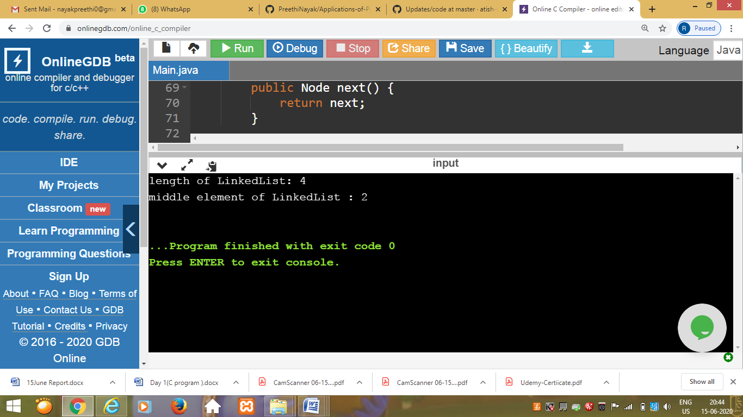

**Programming in C**

Today’s Exercise:-

Problem Statement:-

1.Write a C program to count distinct elements in an array.

Uploaded in :- <https://github.com/PreethiNayak/Programming-in-C/tree/master/Day1>

### Workshop on “Applications of Python Programming in DA and ML”

Today’s exercise uploaded in :- <https://github.com/PreethiNayak/Applications-of-Python-Programming-in-DA-ML->